Abstract
The Advanced eXtensible Interface (AXI4) protocol, part of the ARM AMBA specification, is widely adopted in modern SoC designs due to its high performance and flexibility. This work focuses on the design and implementation of an AXI4-Lite Slave interface with support for read and write transactions, ensuring proper synchronization through valid/ready handshaking. The design has been modeled in Verilog HDL and verified using QuestaSim simulation environment, making it suitable for FPGA-based applications.
The slave design implements all five essential AXI4-Lite channels: write address, write data, write response, read address, and read data. Each channel follows the handshake protocol, ensuring reliable data transfer between the master and slave. A finite state machine (FSM) governs the transition between states such as IDLE, WRITE CHANNEL, RADDR CHANNEL, RDATA CHANNEL, and WRESP CHANNEL. This guarantees proper sequencing and prevents data hazards during concurrent read and write operations.
To validate the functionality, a testbench was developed that initiates both write and read requests from the master side. Simulation results confirm that the slave responds correctly by capturing write data, issuing write responses, and returning the requested read data in compliance with the AXI4-Lite protocol. The observed waveforms demonstrate correct assertion of AWVALID/AWREADY, WVALID/WREADY, BVALID/BREADY, ARVALID/ARREADY, and RVALID/RREADY signals. These results highlight the correctness of the FSM and the robustness of the interface logic.
The implemented AXI4-Lite Slave design provides a reliable foundation for integration into larger systems such as memory-mapped peripherals, FIFOs, or custom IP blocks. By ensuring protocol compliance, modularity, and reusability, the design can be easily extended to support AXI4-Full or AXI4-Stream interfaces for higher performance requirements. This work demonstrates the effectiveness of HDL-based modeling and simulation in achieving functional and timing-correct AXI subsystems for SoC applications.

Table of Contents
Abstract…………………………………………………………………………………...i
Table of contents…..……………………………………………………………………..ii
List of Figures …………………………………………………………………………...iv
Chapter 1- Introduction…………………………………………………………….......1- 9
  - Motivation …………………………………………………………….....1
  - Problem Statement…………………………………………………...…..3
  - Objectives ……………………………………………………………......5
  - Organization of Report………………………………………………........9

Chapter 2-Literature Survey………………………………………………………….10 - 12
Chapter 3-System Design and Implementation…………………………………..…13 - 29

  - Architecture of AXI4 …………… …………………………………....13
  - Asynchronous FIFO Core Design……………………………………..18
  - Verification Environment………………………………………………21
  - Master Slave Interface…………………………………………………..24
  - Implementation …………………………………………………………27

Chapter 4-Results and Discussion…………………………………………………..30 - 35

Chapter 5-Conclusion and Future Scope…………………………………………....36 - 40
References……………………………………………………………………………..29

List of Figures
Figure No. | Description | Page No
3.1 | AXI4 Channels | 13
3.3 | FSM of AXI4 Slave | 21
3.4 | Master Slave Interface | 24
3.5 | Blockdiagram | 27
4.1.1 | Initial Signal Dump of AXI4-Lite Slave Module | 31
4.1.2 | Schematic View of Testbench and DUT Connectivity | 32
4.1.3 | Simulation Waveforms | 33

Chapter 1
INTRODUCTION
In today’s era of rapidly evolving semiconductor technology, System-on-Chip (SoC) designs have become the backbone of modern electronic systems, powering everything from smartphones to autonomous vehicles. These SoCs integrate multiple high-performance components such as processors, accelerators, and peripherals onto a single chip, which creates an urgent need for reliable and high-throughput on-chip communication protocols. To address this, the AMBA (Advanced Microcontroller Bus Architecture) family of standards has emerged as the industry benchmark, evolving through APB and AHB to the highly scalable and parallel AXI (Advanced eXtensible Interface) protocol.
Despite the efficiency of AXI, modern SoCs face a fundamental challenge: clock domain crossing (CDC). Different subsystems within an SoC often operate on independent clock domains, and directly transferring data across them can lead to metastability, data corruption, or protocol violations. Traditional synchronous FIFOs struggle in such environments, especially when required to support packetized streaming data with strict timing guarantees. This creates a pressing demand for a robust asynchronous FIFO solution that not only bridges clock domains but also maintains AXI4-Stream protocol integrity (tvalid, tready, tlast).
Conventionally, designers rely on ad-hoc synchronization mechanisms or vendor-specific IPs to handle CDC, but these approaches can be opaque, difficult to customize, and challenging to verify. They may work for simple transfers, but in high-performance applications involving variable packet sizes, burst transfers, and continuous streaming, even a small design flaw can lead to catastrophic system failures. Such vulnerabilities underline the importance of building a parameterized, reusable, and verification-friendly.
Ultimately, this project demonstrates how a well-verified AXI4 Asynchronous FIFO can serve as an industry-relevant, reusable IP block, directly applicable to modern SoCs. By combining parameterized design with UVM-based verification, the work not only ensures functional correctness but also contributes to scalability, reliability, and reusability qualities that are critical in today’s semiconductor industry.

However, such integration introduces significant on-chip communication challenges. As each subsystem may operate on an independent clock domain, transferring data between them safely and reliably becomes a critical design concern. Clock domain crossing (CDC) issues, if not addressed correctly, can lead to metastability, data corruption, and protocol violations, potentially causing catastrophic system failures. In addition, the increasing demand for high-throughput streaming applications, such as video processing, AI accelerators, and network packet handling, further complicates the problem.
The AMBA (Advanced Microcontroller Bus Architecture) family of standards has long served as the industry benchmark for on-chip communication. It has evolved from APB and AHB interfaces to the highly scalable AXI (Advanced eXtensible Interface) protocol, which supports parallel, high-performance, and packetized data transfers. While AXI provides a robust framework for communication within SoCs, it is not inherently equipped to handle asynchronous transfers between independently clocked domains, especially when continuous streaming or burst data transfers are involved.
Traditional synchronous FIFO buffers are effective in single-clock environments but struggle with CDC scenarios, particularly when strict timing and AXI4-Stream protocol adherence (tvalid, tready, tlast) are required. Ad-hoc synchronization mechanisms or vendor-specific IPs are often used as workarounds. While these solutions may function adequately for simple designs, they are typically opaque, inflexible, and difficult to verify. In high-performance SoCs, even a minor flaw in handling variable packet sizes or continuous burst transfers can compromise the reliability and functional correctness of the entire system.
This scenario underscores the importance of designing a parameterized, reusable, and verification-friendly asynchronous FIFO. A robust solution should not only ensure safe clock domain crossing but also maintain full protocol integrity, making it directly applicable to modern SoC designs. By creating such a design as a reusable IP block, engineers can reduce development time, minimize risk, and enhance scalability for future SoC projects.
Furthermore, verification plays a critical role in ensuring the robustness of the design. The use of UVM (Universal Verification Methodology) provides a structured, reusable, and automated framework to verify the asynchronous FIFO across multiple scenarios, including variable packet sizes, backpressure conditions, and timing variations.
This approach ensures that the design is reliable, reusable, and industry-ready, aligning with the current requirements of semiconductor companies that demand scalable and well-verified IP solutions.
In summary, this project demonstrates how a well-verified AXI4 Asynchronous FIFO can bridge the gap between high-performance subsystems operating on independent clocks. It highlights the importance of parameterized design, protocol compliance, and rigorous verification, which collectively contribute to scalability, reliability, and reusability — qualities that are increasingly critical in the design of next-generation SoCs. By addressing both design and verification challenges, the work provides a practical, industry-relevant IP solution that can serve as a foundational building block for modern semiconductor applications.
  - Motivation
Modern System-on-Chip (SoC) designs integrate multiple processing units, accelerators, and peripherals, each often operating on independent clock domains. While this architectural diversity enhances performance and flexibility, it also introduces a critical challenge: reliable communication across clock boundaries. If data is not transferred correctly between asynchronous domains, issues such as metastability, protocol violations, or even complete system failures can occur. In high-performance applications like networking, AI accelerators, and real-time embedded systems, even a single data loss or timing violation can compromise the entire system.
Traditional methods, such as synchronous FIFOs or vendor-specific black-box IPs, are not always sufficient. Synchronous FIFOs cannot handle mismatched clock domains effectively, while proprietary IP blocks often lack transparency, making them harder to customize and verify. These limitations highlight a clear gap between the demand for reliable, high-throughput data transfer and the availability of reusable, verifiable solutions in the open design space.
The AXI4 protocol, part of the AMBA standard, has emerged as the de facto choice for high-speed, packetized communication in SoCs. However, ensuring protocol integrity (tvalid, tready, tlast) while transferring data across asynchronous domains requires careful design and rigorous verification. This is where an AXI4 Asynchronous FIFO becomes essential.
This project was motivated by the need to design a parameterized, reusable, and industry-relevant FIFO IP that not only bridges clock domains but also integrates seamlessly with AXI4-Stream logic for packetized communication. By combining design with a UVM-based verification environment, the work ensures thorough testing under varied scenarios such as backpressure, random clock ratios, and edge cases like overflow and underflow.
The motivation lies in the belief that robust, verified, and reusable FIFO IPs are vital building blocks for the semiconductor industry. By addressing challenges in clock domain crossing and protocol compliance, this project contributes to the development of scalable, high-performance SoCs while also aligning with industry practices in verification and IP design.
Traditionally, designers have relied on synchronous FIFO buffers or vendor-provided IP blocks to manage clock domain crossings. However, both approaches have significant limitations:
Synchronous FIFOs: These are generally designed for environments where read and write operations share the same clock or operate in closely synchronized domains. When the clocks are asynchronous, synchronous FIFOs may not reliably transfer data. They can introduce timing hazards, data corruption, or metastable states, which are unacceptable in high-speed or critical applications.
Vendor-specific IPs: While these IP cores can offer functional solutions, they are often opaque black boxes. Designers have limited visibility into the internal implementation, making it difficult to customize the IP to specific SoC requirements. Moreover, verifying these IPs under corner cases, varying packet sizes, burst transfers, or high-throughput streaming scenarios can be extremely challenging, which reduces confidence in system reliability.
These challenges highlight a significant gap in the open design space: there is a strong demand for FIFO designs that are robust, reusable, and fully verifiable, capable of handling high-throughput asynchronous data transfer while maintaining protocol integrity.
The AXI4 protocol, part of ARM’s AMBA standard, has emerged as the industry benchmark for high-speed, packetized communication in modern SoCs. AXI4-Stream interfaces are widely used for streaming data applications, supporting variable packet sizes, burst transfers, and handshake signals such as tvalid, tready, and tlast. These features make AXI4 ideal for connecting diverse subsystems, including processors, DMA controllers, and accelerators.
However, ensuring AXI4 protocol compliance across asynchronous domains is non-trivial. Simply connecting an AXI4 stream between independent clock domains can lead to data corruption, lost packets, or backpressure issues. This necessitates the design of a robust asynchronous FIFO, which can safely bridge clock domains while preserving AXI4-Stream semantics.
The primary motivation for this project was to design a parameterized, reusable, and industry-relevant FIFO IP that not only bridges clock domains but also integrates seamlessly with AXI4-Stream logic for packetized communication. The design aims to:
- Safely handle asynchronous clocks to prevent metastability.
- Preserve AXI4-Stream protocol integrity (tvalid, tready, tlast).
- Support variable packet sizes, backpressure, and burst transfers.
- Be parameterized for easy reuse across different SoC designs.
Additionally, the project incorporates a UVM-based verification environment. This enables rigorous testing under multiple scenarios, including random clock ratios, backpressure conditions, edge cases such as FIFO overflow and underflow, and high-throughput streaming. Such comprehensive verification ensures that the FIFO is robust, reliable, and industry-ready.
  - Problem Statement :
Modern System-on-Chip (SoC) designs have grown increasingly complex due to the integration of multiple processing cores, hardware accelerators, memory interfaces, and a wide variety of peripheral modules on a single chip. This level of integration has transformed the landscape of digital system design by enabling high-performance computing in compact, energy-efficient silicon. Central to the functioning of these designs is the communication infrastructure that allows different modules to exchange data efficiently and reliably. Among the available standards for on-chip communication, the AMBA Advanced eXtensible Interface (AXI) protocol has become one of the most widely adopted due to its scalability, high throughput, and flexibility. AXI supports both memory-mapped and streaming data transfers, making it suitable for high-performance subsystems as well as low-bandwidth peripheral connections. In particular, AXI4-Lite, a simplified variant of AXI4, is extensively used for controlling low-bandwidth peripherals such as timers, GPIOs, UARTs, and configuration registers. Despite its simplicity relative to full AXI4, AXI4-Lite presents significant verification challenges, especially when ensuring correctness, reliability, and compliance with the protocol specification across different SoC designs.
One of the main challenges in modern SoC design is verifying the correctness of bus interfaces such as AXI4-Lite under the wide variety of operating conditions that can occur in real-world deployments. Each AXI transaction involves strict handshaking rules, timing constraints, and signal dependencies. Directed or manual testing approaches, where specific test cases are written to exercise the design, often fail to cover the full spectrum of possible interactions between the master and slave devices. These approaches are not only time-consuming but also limited in scope. They are usually designed to test specific scenarios and are not flexible enough to discover subtle corner cases that may occur under unusual timing sequences, rare backpressure conditions, or in the presence of simultaneous multiple transactions. As SoC designs scale up in size and complexity, the probability of undetected functional or timing bugs in AXI4-Lite slave modules increases. Such bugs, if discovered late in the design cycle or post-silicon, can lead to costly re-spins, delayed product releases, and significant financial and reputational losses for semiconductor companies.
Traditional verification methods also suffer from a lack of standardization and reusability. In many design teams, test environments for AXI4-Lite interfaces are often built from scratch for each project. These environments are frequently fragmented, consisting of custom test benches with hard-coded signal interactions, making them difficult to maintain, extend, or adapt to new designs. This approach not only increases the time and effort required to verify each IP but also reduces confidence in the completeness of verification coverage. When multiple teams are working on different parts of the same SoC or across different projects, the lack of a standardized verification methodology results in inconsistent testing practices, further increasing the risk of functional bugs and integration issues.
Given these challenges, there is a clear need for a structured, automated, and reusable verification solution for AXI4-Lite interfaces. Such a solution should provide comprehensive coverage across a wide range of possible scenarios, including normal transactions, boundary conditions, timing violations, and protocol-specific corner cases. It should also enable scalable verification that can be reused across multiple projects, reducing overall verification effort and improving productivity.
The Universal Verification Methodology (UVM), built on top of SystemVerilog, provides a structured approach to meet these verification needs. UVM enables the creation of modular, reusable verification components, promotes constrained-random testing, supports functional coverage, and allows integration of assertion-based verification. Using UVM, verification engineers can generate randomized test scenarios that simulate a wide range of conditions, including rare and complex interactions that may not be evident during directed testing. This approach significantly enhances the probability of detecting subtle functional errors, protocol violations, or timing issues that could otherwise escape detection. Assertions can be used to continuously monitor critical signals and protocol behavior, providing immediate feedback when a violation occurs. Functional coverage metrics enable the verification team to quantify the extent to which the design has been exercised and identify untested or under-tested areas, ensuring that the verification process is both thorough and measurable.
AXI4-Lite interfaces are particularly critical because they connect the main processing cores to low-bandwidth peripherals that control system functionality and configuration. Any failure in these interfaces can propagate through the system, leading to incorrect operation of critical modules, malfunctioning peripherals, or even total system instability. For instance, a timing violation or lost transaction in a control register write operation could cause a hardware module to be misconfigured, resulting in unpredictable behavior. Therefore, developing a verification environment that not only validates data transfer but also ensures protocol compliance and correct handling of edge cases is essential for maintaining overall system reliability.
The verification challenge is further complicated by the need to support diverse clock domains, asynchronous resets, and backpressure scenarios. In modern SoCs, AXI4-Lite slaves may interact with multiple masters operating at different frequencies. Handling these asynchronous interactions correctly is crucial to prevent data corruption and maintain system stability. Moreover, backpressure, where the slave indicates it cannot accept new transactions immediately, must be managed correctly to avoid deadlocks, dropped data, or protocol violations. A robust verification environment should simulate these conditions effectively to confirm that the design behaves correctly under all expected and unexpected operating scenarios.
This project addresses these challenges by developing a comprehensive UVM-based verification environment for AXI4-Lite slave interfaces. The environment includes configurable, reusable test components such as drivers, monitors, scoreboards, and sequencers. These components are designed to interact seamlessly, enabling constrained-random test generation, assertion-based monitoring, and functional coverage analysis. By combining these techniques, the verification environment ensures that all aspects of AXI4-Lite protocol compliance are thoroughly tested, including correct handling of read and write transactions, proper assertion of handshake signals, and correct behavior under simultaneous and random transaction sequences.
The project also emphasizes reusability and scalability. The verification environment is designed to be parameterized, allowing it to be adapted easily for different AXI4-Lite IPs, system configurations, or SoC architectures. This modular approach significantly reduces verification time for future designs, allows teams to leverage previously validated test components, and promotes consistency across projects. As a result, verification engineers can focus on higher-level functional validation rather than spending time building test benches from scratch for each new design.
Ultimately, the development of a structured, UVM-based verification environment for AXI4-Lite addresses multiple critical needs in modern SoC design. It provides automation, reduces manual intervention, increases coverage, and enhances confidence in the functional correctness and protocol compliance of peripheral interfaces. It also supports long-term maintainability and adaptability, ensuring that the verification framework remains useful for evolving designs and future projects. By providing a reusable, industry-grade solution, this project contributes not only to the reliability of individual AXI4-Lite IPs but also to the overall robustness, scalability, and quality of modern semiconductor systems.
In summary, the problem this project addresses is the gap between the increasing complexity of AXI4-Lite interfaces in modern SoCs and the limitations of traditional verification methods. By leveraging SystemVerilog and UVM methodologies, this work provides a comprehensive, scalable, and reusable solution that ensures functional correctness, protocol compliance, and reliability across a wide range of scenarios, supporting the development of high-performance, robust, and industry-ready semiconductor products.
  - Organization of Report
This project report is systematically organized into five chapters to present the work in a clear and logical manner. Chapter 1 introduces the project by outlining the motivation behind selecting the topic, the problem statement, and the specific objectives of the work. It also describes the scope and importance of the project, along with an overview of the entire report structure. Chapter 2 provides a detailed literature survey, summarizing existing research and related works in the area. This chapter highlights the contributions of earlier studies and identifies the research gaps that this project aims to address. Chapter 3 focuses on the methodology adopted for the project. It includes the description of tools and software requirements, the design methodology, and the representation of the system through block diagrams and flow charts, ensuring clarity in the implementation approach. Chapter 4 presents the simulation results, observations, and a detailed analysis of outcomes obtained during verification. This chapter demonstrates how the objectives were achieved and validates the correctness of the design. Finally, Chapter 5 concludes the report by summarizing the key findings, reflecting on the contributions, and suggesting potential improvements and directions for future research. References are provided at the end..

Chapter 2
LITERATURE SURVEY
[1.] Research on UVM Verification Platform Based on AXI4 Protocol Intellectual Property.This paper focuses on building a UVM verification platform for an AXI4 IP core (AXI4 RAM). The platform includes reusable, portable Universal Verification Components (UVCs), and verifies read/write functionality under constrained-random stimulus. It also achieves high functional coverage (100%) for the DUT under test. The environment uses driver, monitor, scoreboard, and reference model components to compare expected vs actual behavior. Useful for your project to see how to build UVM agents and ensure coverage and portability.
[2.] Amba-AXI Protocol Verification by Using UVM (P. Naveen Kalyan & K. Jaya Swaroop) around 2019-2020.This work implements UVM to verify AXI read & write transactions, both in same and different address locations. They built a test environment with various test scenarios, monitored handshake signals and verified bus utilization. They also check code coverage and waveform behavior for AW, W, AR, R channels. This gives good insight for how to structure test cases and which signals to monitor.
[3.] Design of AXI4 Master & Slave UVCs using UVM. IJIRT Published Paper (recent).
This paper presents design of reusable AXI4 Master and AXI4 Slave UVCs using UVM for efficient verification of AXI4 protocol-based SoC design. The environment supports different burst types (FIXED, INCR, WRAP), aligned/unaligned accesses, narrow transfers, out-of-order transactions. Both directed and constrained-random tests were used. The functional coverage achieved is around 83%. Useful for your project in setting up UVCs and planning your burst/unaligned test scenarios.
[4.] Improvements in UVM-based AXI Verification IP (Master’s Thesis, Nokia). 2024.
This thesis describes developing and improving a UVM-based AXI4 Verification IP (VIP) internally, which supports the full AXI protocol. It includes constrained-random testing, coverage-driven verification, and interoperability testing. This is relevant for learning how to make your verification environment more robust and reusable.
[5.] UVM based Design Verification of FIFO (2025). (Synchronous FIFO)
While this paper is focused on a synchronous FIFO (not asynchronous), it is very useful for methods / testbench components: how to verify read/write functionality, full/empty flags, edge case behavior (overflow/underflow), and using UVM components like drivers, monitors, scoreboards. Provides good reference for what to do when you integrate FIFO in your later project phases.
[6.] A Review on Design and Verification of Programmable AXI-Bus / Memory Interface using UVM (Basavaiah, et al.). IJFMR, 2024.
This paper discusses design challenges and verification of AXI (single / burst data transfers) with Verilog HDL plus SystemVerilog assertions. Good for understanding what verification checks are important, and what trade-offs are involved, especially for coverage complexity.

[7.] Research on UVM Verification Platform Based on AXI4 Protocol Intellectual Property

This work focuses on the development of a UVM-based verification platform for an AXI4 RAM IP core. The authors designed reusable and portable Universal Verification Components (UVCs) that could be integrated across projects. The platform validated AXI4 read and write functionality under constrained-random stimulus and achieved 100% functional coverage for the DUT. The verification environment incorporated drivers, monitors, scoreboards, and a reference model to ensure correctness by comparing expected vs. actual behavior.
8.] UVM Based Verification for Asynchronous FIFO (Conference Paper, 2024)

This work presents a UVM verification environment for asynchronous FIFO designs. Independent UVCs were created for the write domain and read domain, with drivers, monitors, a scoreboard, and functional coverage bins. Randomized sequences validated FIFO robustness under different clock ratios and burst patterns.
Relevance: Closely matches the scope of this project’s Phase-2 UVM verification, serving as a blueprint for environment architecture.

[9.] UVM Verification IP for AXI Protocol (Melikyan & Harutyunyan, Semantic Scholar)

The study introduces a reusable AXI Verification IP designed in UVM. It provides configurable transactions, drivers, sequencers, and monitors for all AXI channels. The environment emphasized protocol compliance, with checkers to detect handshake violations and constrained-random stimulus for functional coverage.
Relevance: Useful for developing AXI-compliant verification agents for the FIFO, ensuring the interface logic remains standard-compliant.

[10.] Design and Verification of a Synchronous FIFO (Yatheeswar Penta & Riadul Islam, arXiv, 2025)

This study implements a synchronous FIFO in Verilog and verifies it with both directed and UVM-based constrained-random stimulus. The authors applied coverage bins to ensure that all FIFO states and transitions were exercised. The work demonstrated effective handling of overflow, underflow, and boundary conditions.
Relevance: Although synchronous, the methodology (directed + constrained-random + coverage bins) can be mirrored for the asynchronous FIFO in this project.

Chapter 3
SYSTEM DESIGN AND IMPLEMENTATION
The design and implementation of the AXI4 Asynchronous FIFO system form the core of this project. This chapter presents the complete architecture, functional design, and verification of the developed modules. The system has been divided into two primary components: the AXI4-Lite Slave interface, which handles memory-mapped read and write operations, and the Asynchronous FIFO core, which stores and transfers data safely between different clock domains. Both modules were implemented using Verilog HDL and integrated into a testbench environment for functional verification. To clearly represent the design flow, block diagrams, finite state machine (FSM) diagrams, and RTL code structures are included along with detailed explanations of each stage.

3.1 Architecture of AXI4 System :

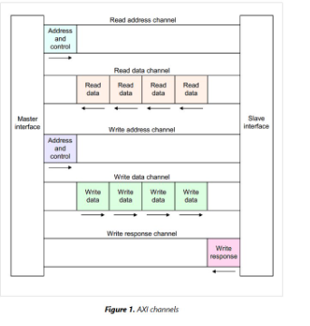
Fig 3.1: AXI4 Channels

As illustrated in Figure 3.1, the architecture of the AXI4 Asynchronous FIFO has been designed to provide a reliable data-transfer mechanism across two independent clock domains while supporting AXI4 protocol features, the design connects an AXI4 Slave Interface (for data input) with an AXI4 Lite Master Interface .
The use of an asynchronous FIFO enables safe and efficient clock-domain crossing, ensuring metastability protection and maintaining data integrity. Such designs are particularly critical in SoCs, communication systems, and high-performance embedded platforms where modules operate at different clock frequencies.

System Components
- AXI4 Slave Interface (Input Side) – Receives data, write enable, and associated handshake signals.
- Asynchronous FIFO Core – Performs storage, manages write and read pointers, synchronizes status signals across clock domains, and ensures reliable data transfer.
- AXI4 Master Interface (Output Side) – Reads data from FIFO, drives handshake signals, and provides outputs to downstream modules.
- Verification Testbench – Integrates FIFO with AXI4 protocol drivers, applies test stimuli, and verifies functionality under different conditions.

System Signals
• ACLK – Global clock for AXI transactions (both read and write).
• ARESETN – Active-low reset, initializes the AXI slave FSM to the IDLE state.
• M_AWADDR[31:0] – Write address bus driven by the master, captured by the slave in WRITE CHANNEL.
• M_AWVALID / S_AWREADY – Handshake signals for write address phase. Transaction starts when both are high.
• M_WDATA[31:0] – Write data bus, accepted by the slave in WCHANNEL after address is valid.
• M_WVALID / S_WREADY – Handshake signals for write data phase.
• S_BVALID / M_BREADY – Write response channel signals. Slave asserts BVALID after data is written; master responds with BREADY.
• M_ARADDR[31:0] – Read address bus, captured by the slave in RADDR CHANNEL.
• M_ARVALID / S_ARREADY – Handshake signals for read address phase.
• S_RDATA[31:0] – Read data bus provided by the slave in RDATA CHANNEL.
• S_RVALID / M_RREADY – Handshake signals for read data transfer. Slave asserts RVALID when data is available; master asserts RREADY to accept.
• S_RRESP[1:0], S_BRESP[1:0] – Response signals indicating success or error of read/write operations.
The AXI4 Asynchronous FIFO architecture plays a critical role in bridging two independent clock domains while maintaining high data integrity and protocol compliance. Modern System-on-Chip (SoC) designs often integrate multiple modules that operate at varying clock frequencies due to performance and power optimization requirements. These modules need to exchange data efficiently without causing metastability, data corruption, or protocol violations. The AXI4 asynchronous FIFO provides a reliable mechanism to safely transfer data between these domains, ensuring that system functionality is maintained under high-throughput conditions. As illustrated in Figure 3.1, the design connects an AXI4 slave interface on the input side with an AXI4 master interface on the output side, creating a seamless data path that is compatible with AXI4 protocol handshakes and signaling.
The use of an asynchronous FIFO is particularly crucial in SoCs, high-performance embedded platforms, and communication systems where modules operate independently and may have varying latency requirements. The FIFO provides buffering and synchronization, which absorbs differences in clock rates and allows continuous data flow without dropping transactions. By decoupling the producer and consumer sides, the design ensures that write operations on the slave interface and read operations on the master interface can proceed independently, with full protection against metastability and data loss.
The system architecture comprises four primary components. The first is the AXI4 slave interface, which is responsible for receiving data, write enable signals, and associated handshake signals from upstream modules. It captures the write address and write data and initiates transactions based on AXI4 handshake rules. The second component is the asynchronous FIFO core itself, which performs the central function of storing data, managing write and read pointers, and synchronizing status signals across clock domains. The FIFO core ensures that no data is lost or corrupted while transferring between asynchronous clocks. The third component is the AXI4 master interface on the output side, which reads data from the FIFO and drives handshake signals to downstream modules. It guarantees that AXI4 protocol timing and validity requirements are satisfied during read operations. Finally, the verification testbench integrates the FIFO with AXI4 protocol drivers, applies varied test stimuli, and verifies functionality under different operating conditions. This testbench is essential for confirming the robustness and correctness of the design across multiple scenarios, including backpressure, burst transfers, and varying clock frequencies.
The system relies on several critical signals to maintain proper operation. The global clock for AXI transactions, ACLK, provides timing for both read and write channels. The active-low reset signal, ARESETN, initializes the AXI slave finite state machine (FSM) to the idle state, ensuring that the system starts in a known configuration. On the write side, M_AWADDR[31:0] carries the address for write operations, while M_AWVALID and S_AWREADY form the handshake that signals when the address is valid and ready for processing. The write data bus, M_WDATA[31:0], carries the data, and the corresponding handshake signals M_WVALID and S_WREADY ensure proper timing and validation of the write phase. The write response channel, consisting of S_BVALID and M_BREADY, informs the master when a write has been successfully completed. On the read side, M_ARADDR[31:0], M_ARVALID, and S_ARREADY manage the read address phase, while S_RDATA[31:0], S_RVALID, and M_RREADY handle data delivery during the read transaction. Additional response signals, S_RRESP[1:0] and S_BRESP[1:0], indicate the success or error status of read and write operations, completing the AXI4 protocol compliance requirements.
The asynchronous FIFO core itself is designed with a dual-clock architecture, which allows safe and reliable data transfer between the write and read domains, each operating at independent frequencies. At the heart of this design is the memory array, which serves as a parameterized buffer capable of storing multiple data words. The depth and width of this array can be adjusted depending on system requirements, allowing flexibility in managing high-throughput data streams. Complementing the memory array are the write and read pointer logic modules. The write pointer logic, wptr, operates on the slave clock domain, incrementing each time a valid write is performed. The read pointer logic, rptr, operates on the master clock domain, incrementing each time a valid read occurs. These pointers are critical for tracking the current positions in the FIFO and ensuring that data is not overwritten or read before it is valid.
To address the challenges of crossing clock domains, the FIFO employs pointer synchronization techniques. Gray coding is used for the write and read pointers before synchronization, which ensures that only a single bit changes at a time during transitions, minimizing the risk of metastability. Double-flop synchronizers are then used to safely transfer these pointer values between clock domains. By comparing the synchronized write and read pointers, the status logic determines full and empty conditions for the FIFO, which are crucial for preventing data overflows or underflows. This combination of gray coding and double-flop synchronization ensures robust clock domain crossing and reliable operation of the FIFO in diverse operating conditions.
In addition to pointer logic, the AXI4 protocol is implemented using finite state machines on both the write and read sides. The write-side FSM in the slave domain follows a sequence of IDLE, WAIT_VALID, WRITE, and UPDATE_PTR states. This FSM ensures that write transactions are only initiated when valid data and addresses are present, that handshakes are respected, and that the write pointer is correctly updated after each transaction. Similarly, the read-side FSM in the master domain follows IDLE, CHECK_DATA, READ, and UPDATE_PTR states, ensuring that read operations occur only when data is available, that handshake signals are correctly asserted, and that the read pointer is updated accordingly. These FSMs integrate tightly with the pointer logic and memory array to maintain AXI4 protocol compliance while managing asynchronous data flow.
The verification of the asynchronous FIFO is equally critical. A dedicated testbench simulates a wide variety of operating scenarios, including normal read and write transactions, burst transfers, random clock ratios, and extreme conditions such as backpressure, overflow, and underflow. By applying constrained-random testing and assertion-based checks, the verification environment ensures that all aspects of the FIFO, from pointer synchronization to AXI4 handshakes, operate correctly under all conditions. Functional coverage metrics are collected to confirm that corner cases are adequately tested, providing a high degree of confidence in the design’s correctness and reliability.
Overall, the AXI4 asynchronous FIFO architecture is a robust and reusable solution for bridging independent clock domains in modern SoCs. By combining dual-clock memory arrays, pointer synchronization, FSM-based control, and AXI4-compliant interfaces, the design ensures reliable, high-throughput data transfer. The verification framework guarantees protocol adherence and functional correctness, making the FIFO suitable for integration into a wide range of applications, including communication systems, high-performance embedded platforms, and complex SoC architectures. This comprehensive design and verification approach addresses the increasing demands of modern semiconductor systems, providing both reliability and scalability for current and future designs.

3.2 Asynchronous FIFO Core Design
The FIFO is the heart of the system. It uses dual-clock architecture to allow safe data transfers between write and read domains operating at different frequencies.

Internal Components
- Write Pointer Logic (wptr) – Operates on s_axis_aclk and increments on each valid write.
- Read Pointer Logic (rptr) – Operates on m_axis_aclk and increments on each valid read.
- Memory Array – A parameterized depth × width buffer to store data.
- Pointer Synchronization – Uses Gray coding and double-flop synchronizers to safely transfer pointer values across domains.

Status Logic – Determines full and empty conditions by comparing synchronized pointers. FSM-Based Control
While FIFO itself is pointer-based, the AXI4 handshake protocol is implemented using simple FSMs on both sides:
- Write-Side FSM (Slave Domain):
  - IDLE → WAIT_VALID → WRITE → UPDATE_PTR
- Read-Side FSM (Master Domain):
  - IDLE → CHECK_DATA → READ → UPDATE_PTR
These FSMs ensure AXI4 protocol compliance and proper data movement.
The FIFO, or First-In-First-Out memory buffer, serves as the central component of the AXI4 asynchronous FIFO system. It is designed using a dual-clock architecture, which allows it to transfer data safely between the write and read domains, even when these domains operate at different clock frequencies. This dual-clock structure is critical in modern SoCs, where different modules may run at varying speeds for performance optimization, and reliable data transfer must be maintained without causing metastability or data corruption.
The internal components of the FIFO work together to manage the flow of data and ensure synchronization between clock domains. The write pointer logic, known as wptr, operates on the write-side clock (s_axis_aclk). Its primary function is to keep track of the location in the memory array where the next data word should be written. Each time a valid write occurs, the write pointer increments, moving to the next memory location. This ensures that data is written sequentially into the FIFO buffer without overwriting existing entries.
Similarly, the read pointer logic, rptr, operates on the read-side clock (m_axis_aclk). The read pointer tracks the position of the next data word to be read from the FIFO. Each time a valid read occurs, the read pointer increments, moving forward in the memory array. The separation of read and write pointers allows the FIFO to function correctly even when the read and write operations occur at different speeds, which is essential for bridging asynchronous clock domains.
The memory array itself is a parameterized buffer that can be adjusted in both depth and width to suit the needs of the system. The depth determines how many data words the FIFO can store, while the width specifies the number of bits in each data word. This flexibility allows the FIFO to be adapted to different applications, ranging from low-bandwidth peripheral communication to high-speed data streaming in AI accelerators or network-on-chip systems.
Pointer synchronization is another critical aspect of the FIFO design. Since the write and read pointers operate in separate clock domains, directly using these pointers in the opposite domain can cause metastability, leading to unreliable behavior. To prevent this, the FIFO uses Gray coding for the pointers before synchronizing them across domains. Gray coding ensures that only one bit changes at a time during pointer transitions, minimizing the chance of erroneous intermediate states. After Gray coding, the pointers pass through double-flop synchronizers, which safely transfer the pointer values between clock domains. This combination of Gray coding and double-flop synchronization ensures accurate and stable communication between the write and read sides.
Status logic monitors the FIFO to determine full and empty conditions. By comparing the synchronized pointers, the status logic can detect when the FIFO has no more space for new data or when it has no data available to read. This information is critical for preventing overflows, where new data would overwrite unread data, and underflows, where read operations attempt to access invalid data. These full and empty flags are also used to control AXI4 handshaking signals, ensuring proper communication between connected modules.
While the FIFO core itself is primarily pointer-based, the AXI4 protocol requires handshake signals for both write and read operations. To manage this, finite state machines (FSMs) are implemented on both the write and read sides. The write-side FSM operates in the slave domain and follows a sequence of states: IDLE, WAIT_VALID, WRITE, and UPDATE_PTR. In the IDLE state, the FSM waits for a valid write request. When the master asserts a valid write, the FSM transitions to WAIT_VALID and then to the WRITE state, where the data is stored in the FIFO. After the write is complete, the FSM updates the write pointer and returns to the IDLE state, ready for the next transaction.
The read-side FSM operates in the master domain and follows the states: IDLE, CHECK_DATA, READ, and UPDATE_PTR. In the IDLE state, the FSM waits for data to be available in the FIFO. When data is detected, it transitions to CHECK_DATA to confirm validity, then to READ, where the data is output to the master interface. Finally, it updates the read pointer and returns to the IDLE state. These FSMs are essential for maintaining AXI4 protocol compliance, ensuring that handshake signals are correctly managed and that data is transferred safely and accurately across the FIFO.

3.3 AXI4 Slave Design
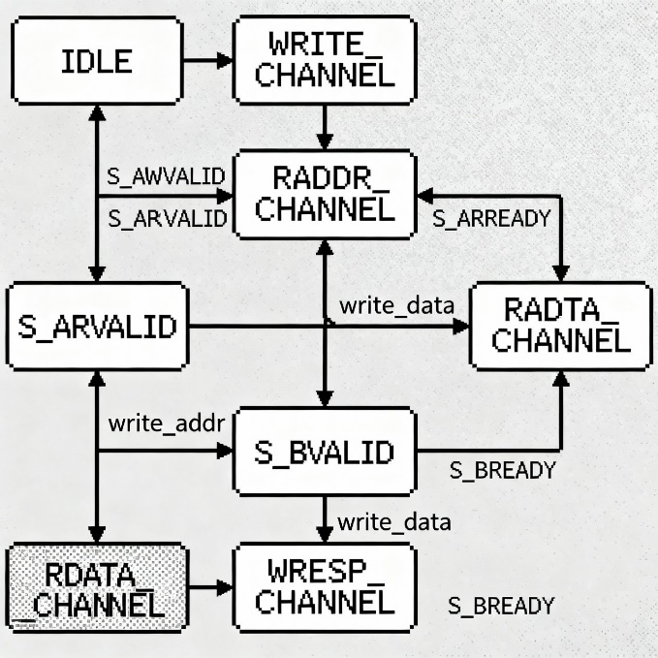
Fig 3.3 : FSM of AXI4 Slave
The figure 3.4.1 illustrates the state machine design of an AXI4 Slave interface, which is responsible for handling read and write transactions through multiple channels. The AXI protocol divides operations into independent channels, and the slave must manage handshaking, address decoding, data transfer, and response generation.

IDLE State :
- The design starts in the IDLE state, where the slave waits for a valid request.
- Depending on whether the master initiates a read (S_ARVALID) or write (S_AWVALID) request, the FSM transitions to the corresponding channel.

Write Transaction Path :
- WRITE_CHANNEL
  - Triggered when the master asserts S_AWVALID.
  - The slave acknowledges the address phase.
- RADDR_CHANNEL
- The slave receives and latches the write address.
- Handshaking is completed via S_AWREADY.
- RADTA_CHANNEL
  - The slave accepts the write data (write_data).
  - Synchronization is done with S_WVALID / S_WREADY handshake.
- S_BVALID (Write Response)
  - Once data is successfully written, the slave asserts S_BVALID to indicate a valid write response.
  - The master acknowledges using S_BREADY.
- WRESP_CHANNEL
  - A final write response (OKAY/SLVERR/DECERR) is generated.
  - After this, the FSM returns to IDLE.

Read Transaction Path :
- S_ARVALID
  - When the master asserts S_ARVALID, the slave accepts the read address (write_addr in the diagram).
- RDATA_CHANNEL
  - The slave retrieves the requested data from memory or FIFO.
  - Data is placed on the read data bus and S_RVALID is asserted.
  - The master acknowledges with S_RREADY.
- Completion
  - After the read data is transferred, the FSM returns to IDLE.

Key Signal Interactions :
- S_AWVALID / S_AWREADY → Write address handshake
- S_WVALID / S_WREADY → Write data handshake
- S_BVALID / S_BREADY → Write response handshake
- S_ARVALID / S_ARREADY → Read address handshake
- S_RVALID / S_RREADY → Read data handshake
The AXI4 Slave interface forms a critical component in an SoC, responsible for managing communication between a master and a peripheral or memory module. Its main function is to handle both read and write transactions over the AXI4 bus while ensuring proper adherence to the protocol. The AXI protocol divides operations into independent channels, namely the address, data, and response channels for both read and write operations. The slave interface must coordinate these channels, manage handshakes, decode addresses, transfer data correctly, and generate appropriate responses, all while remaining compliant with timing and signaling requirements.
The overall operation of the AXI4 Slave interface is controlled by a finite state machine (FSM), which is illustrated in figure 3.4.1. The FSM provides a structured way to manage the various stages of transactions, ensuring correct sequencing and robust communication. The FSM begins in the IDLE state, which is the default state when no transaction is in progress. In this state, the slave waits for a valid request from the master. A valid request could be either a read or a write operation. For a write transaction, the master asserts the S_AWVALID signal, indicating that a valid write address and control information are present. For a read transaction, the master asserts S_ARVALID, signaling a valid read address. The FSM detects these signals and transitions to the corresponding channel for the requested operation.
The write transaction path involves multiple stages, each associated with a specific channel of the AXI protocol. The first stage is the WRITE_CHANNEL, which is triggered when the master asserts S_AWVALID. In this stage, the slave acknowledges the incoming write address by asserting S_AWREADY, completing the handshake for the address phase. This ensures that the master knows the slave is ready to accept the address and can proceed to send the corresponding write data.
Next, the RADDR_CHANNEL stage receives and latches the write address. This stage ensures that the address is stored in the slave correctly and will be used to locate the memory or FIFO location where the data will be written. The handshake during this stage is crucial for preventing timing mismatches and ensuring data integrity.

3.4 Master Slave Interface
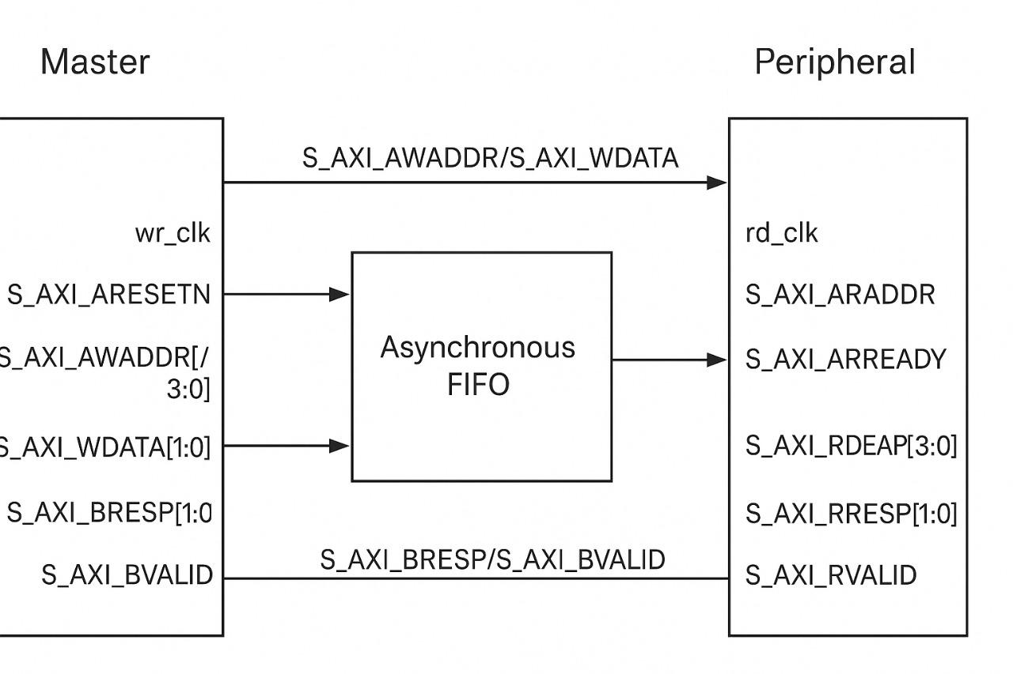
Fig 3.4 : Master Slave Interface

AXI Asynchronous Clock Domain Crossing (CDC) Bridge Implementation
This diagram illustrates the core components and signal flow of an AXI (Advanced eXtensible Interface) Asynchronous Clock Domain Crossing (CDC) Bridge. This bridge is a critical hardware structure used in System-on-Chips (SoCs) to safely connect a high-performance AXI Master component operating in one clock domain to an AXI Peripheral component operating in a separate, asynchronous clock domain.

1. Clock Domains and Control Signals
The system operates across two independent clock domains:
- Master Domain (wr_clk): The clock controlling the Master's operations (often the system clock for write transactions).
- Peripheral Domain (rd_clk): The clock controlling the Peripheral's operations (often the clock for read transactions or the local Peripheral clock).
- S_AXI_ARESETN: This active-low reset signal must be properly synchronized to both wr_clk and rd_clk domains, ensuring all components start in a stable, known state.

2. The Asynchronous FIFO
The central component of the CDC bridge is the Asynchronous FIFO (First-In, First-Out). This specialized memory buffer is designed to safely transfer multi-bit data between the two unrelated clock domains.
- Write Operation: Data is written into the FIFO using the Master's wr_clk.
- Read Operation: Data is read out of the FIFO using the Peripheral's rd_clk.
The FIFO internally uses techniques like Gray Code pointer synchronization to prevent metastability and ensure data integrity during the transfer, effectively decoupling the timing constraints between the Master and the Peripheral.

3. Signal Flow Analysis
The diagram highlights the transfer of key AXI signals, primarily focusing on the Master-to-Peripheral direction through the FIFO and the Peripheral-to-Master direction for responses:

A. Master to Peripheral Flow (via FIFO)
The signals entering the FIFO are driven by the Master on wr_clk. These typically represent the request channels (AW and AR).
- Inputs:
  - S_AXI_AWADDR/[3:0] (Write Address) and S_AXI_WDATA[1:0] (Write Data): These are the address and data bundles for a write request. The diagram shows them entering the FIFO, implying the write request information is buffered before being presented to the Peripheral.
- Outputs:
  - S_AXI_ARADDR (Read Address): This signal exits the FIFO and is presented to the Peripheral on rd_clk. This suggests the FIFO is acting as the buffer for the Read Address Channel (AR), allowing the Master to issue read requests ahead of the Peripheral's processing capability.
  - S_AXI_ARREADY: Driven by the Peripheral on rd_clk, this signal indicates the Peripheral is ready to accept the read address coming out of the FIFO.

B. Peripheral to Master Flow (Response/Data)
The signals flowing from the Peripheral back to the Master contain read data and transaction status. While these are typically transferred using a reverse FIFO for read data or synchronizers for control signals, the diagram shows them as direct signal paths.
- Write Response Channel (B):
  - S_AXI_BRESP/S_AXI_BVALID: The Peripheral asserts the response code (BRESP) and the valid signal (BVALID) on rd_clk. These signals must be synchronized back to the wr_clk domain before reaching the Master.
- Read Data Channel (R):
  - S_AXI_RDEAP[3:0] (Read Data - likely RDATA): The actual data read from the Peripheral.
  - S_AXI_RRESP[1:0] (Read Response): The status of the read transaction.
  - S_AXI_RVALID: The valid indicator for the read data/response.

4. Functionality and Significance
The AXI CDC Bridge performs the vital task of rate matching and safely synchronizing the AXI protocol signals. By using the Asynchronous FIFO for the request channels (Master → Peripheral), the bridge:
- Prevents Metastability: Eliminates the risk of direct clock domain crossing failure on multi-bit address and data buses.
- Improves Throughput: Allows the Master to pipeline transactions and run at its maximum clock speed without waiting for the slower Peripheral to complete its operation. The FIFO absorbs the timing mismatch and ensures transactional integrity across the asynchronous boundary.

3.5 Implementation

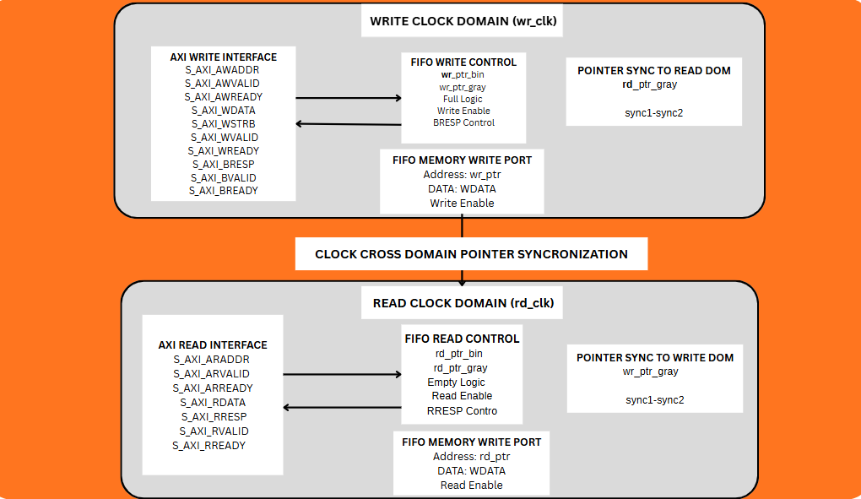
Fig 3.4 : blockdiagram

The Fig 3.4.1 provides a high-level architectural overview of the asynchronous FIFO design, illustrating how the system is partitioned into two distinct clock domains: the Write Clock Domain (wr_clk) and the Read Clock Domain (rd_clk). The diagram highlights the core components and the critical data path for clock domain crossing.
- Write Clock Domain (wr_clk): This domain handles all write operations from the AXI master.
  - AXI Write Interface: This block manages the AXI4-Lite write channels, including the address (S_AXI_AWADDR), data (S_AXI_WDATA), and response (S_AXI_BRESP) signals. It orchestrates the handshakes with the AXI master.
  - FIFO Write Control: This is the core logic for the write side. It includes the write pointers (wr_ptr_bin, wr_ptr_gray) and the logic to determine if the FIFO is full. It generates the Write Enable signal for the FIFO memory.
  - Pointer Sync to Read Domain: This crucial block contains the synchronizer logic that safely transfers the Gray-coded write pointer (wr_ptr_gray) from the write clock domain to the read clock domain. This is essential for the read side to correctly determine the FIFO's empty status without metastability issues.
- Read Clock Domain (rd_clk): This domain handles all read operations from the peripheral.
  - AXI Read Interface: This block manages the AXI4-Lite read channels, handling the read address (S_AXI_ARADDR) and providing the read data (S_AXI_RDATA) and response (S_AXI_RRESP) to the master.
  - FIFO Read Control: This block manages the read pointers (rd_ptr_bin, rd_ptr_gray) and includes the logic for Empty Logic. It generates the Read Enable signal for the FIFO memory.
  - Pointer Sync to Write Domain: This block synchronizes the Gray-coded read pointer (rd_ptr_gray) from the read clock domain to the write clock domain. This allows the write side to correctly determine the FIFO's full status.
- Shared FIFO Memory Port: The FIFO MEMORY WRITE PORT and FIFO MEMORY READ PORT represent the single dual-port memory that serves as the data buffer. The memory is written to on the wr_clk and read from on the rd_clk, which is the fundamental mechanism of an asynchronous FIFO.
- Clock Cross Domain Pointer Synchronization: This central block visually represents the data path for the synchronized pointers, which are the only signals that cross the two clock domains. This is the heart of the asynchronous design, ensuring that the FIFO's status flags (full/empty) are accurate and reliable regardless of the clock frequency difference.
This is a high-level overview of the asynchronous FIFO design, which is structured to operate across two independent clock domains: the write clock domain (wr_clk) and the read clock domain (rd_clk). This design is critical in modern System-on-Chip (SoC) environments, where different modules operate at different clock frequencies to optimize performance, power, and resource utilization. The primary goal of the asynchronous FIFO is to enable safe and reliable data transfer between these domains while maintaining AXI4-Lite protocol compliance.
The write clock domain, or wr_clk domain, handles all write operations originating from the AXI master. Central to this domain is the AXI write interface, which manages the AXI4-Lite write channels. These include the write address bus (S_AXI_AWADDR), the write data bus (S_AXI_WDATA), and the write response signals (S_AXI_BRESP). The write interface is responsible for orchestrating the handshakes with the AXI master. When the master initiates a write operation by asserting the appropriate handshake signals, the write interface validates the request, ensures that the data and address are correctly received, and prepares the data for storage in the FIFO memory.
At the heart of the write domain is the FIFO write control logic. This block contains the write pointers, represented in both binary (wr_ptr_bin) and Gray-coded (wr_ptr_gray) formats, which keep track of the next location in the FIFO memory to be written. The FIFO write control also includes logic to determine whether the FIFO is full, preventing overwriting of unread data. Once the write operation is validated and the FIFO is not full, the control logic generates a Write Enable signal to store the incoming data in the memory array. The Gray-coded write pointer is also passed to a pointer synchronization block that safely transfers it to the read clock domain, allowing the read side to accurately determine the FIFO’s empty status.
The read clock domain, or rd_clk domain, is responsible for all read operations directed toward the peripheral or downstream modules. The AXI read interface in this domain manages the read address bus (S_AXI_ARADDR) and provides read data (S_AXI_RDATA) along with the response signals (S_AXI_RRESP) to the master. When a read request is received, the read interface validates the address, retrieves the corresponding data from the FIFO memory, and asserts the read handshake signals to ensure proper timing and synchronization with the master.
The FIFO read control logic mirrors the functionality of the write control, with pointers that track the current read location in both binary (rd_ptr_bin) and Gray-coded (rd_ptr_gray) formats. The read control block also contains empty logic, which determines whether the FIFO contains any valid data for reading. If data is available, the read control generates the Read Enable signal to fetch data from the memory. Simultaneously, the Gray-coded read pointer is passed to a pointer synchronization block that transfers it safely back to the write domain, allowing the write side to determine if the FIFO is full. This bidirectional pointer synchronization ensures that both domains have accurate status information without introducing metastability or timing errors.
Chapter 4
RESULTS AND DISCUSSION
  - Simulation Results
The simulation of the AXI4-Lite interface design was carried out using Mentor QuestaSim to validate the correctness of the read and write operations. At this stage of the project, the primary objective was to verify the AXI4-Lite protocol signals and handshakes, ensuring that the design responds accurately to standard transactions before integrating the complete FIFO functionality.
The testbench instantiated the AXI4-Lite slave module, while generating the required clock, reset, address, and data stimulus. A reset sequence was first applied to initialize the design, followed by sequences of write and read operations to different memory locations. The correctness of each transaction was checked by comparing the expected data values with the data retrieved from the slave module.
The simulation produced promising results that validated the initial design. The observations are summarized below:
- The write transaction was successfully executed at address 0x100, where the given data (0xDEADBEEF) was stored. The AXI4 handshake signals (awvalid, awready, wvalid, wready) completed as expected, confirming the correctness of the write channel.
- The read transaction was then initiated for the same address, and the design returned the stored value 0xDEADBEEF without corruption. The read channel signals (arvalid, arready, rvalid, rready) behaved as per protocol specifications.
- A second test at address 0x200 also passed successfully, with the data written and read back correctly. This confirms that the design can handle transactions at multiple addresses.
- All control signals across the AXI4 channels (write address, write data, write response, read address, and read data) demonstrated proper synchronization and handshake behavior.
- The simulation logs and waveforms further verified that the state transitions in the AXI4-Lite slave logic occurred correctly during different phases of the transaction.

Overall, the Phase 1 results show that the AXI4-Lite slave design and its verification environment are working correctly. The module is able to accept write transactions, store data, and return the same data on read transactions while maintaining strict protocol compliance. This establishes a strong foundation for extending the project into the next phase, where the asynchronous FIFO functionality will be integrated and verified.

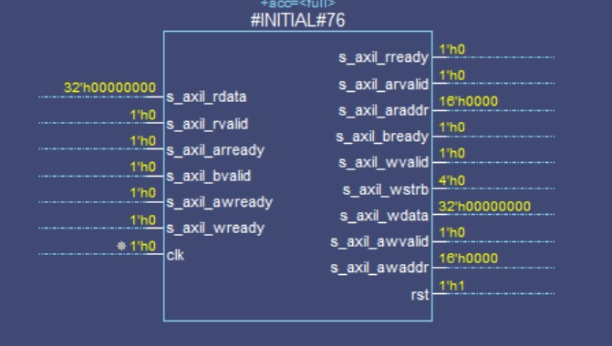

Figure 4.1.1:- Initial Signal Dump of AXI4-Lite Slave Module
The Figure 4.1.1 displays the initial signal values of the AXI4-Lite slave module captured in QuestaSim. At this stage, most of the control signals such as s_axil_awvalid, s_axil_wvalid, and s_axil_arvalid are deasserted (0), indicating that no active transactions are taking place. The reset (rst) is asserted high (1), which ensures that the design is initialized to a known state before starting operations. The read data bus (s_axil_rdata) is set to 0x00000000, confirming that no memory location has yet been accessed. Handshake-related signals like s_axil_awready, s_axil_wready, and s_axil_rready are also inactive, showing that the slave is in an idle state waiting for a valid request. This figure essentially validates the reset functionality and initial state behavior of the AXI4-Lite slave, ensuring that the design does not produce undefined outputs before proper transactions begin.
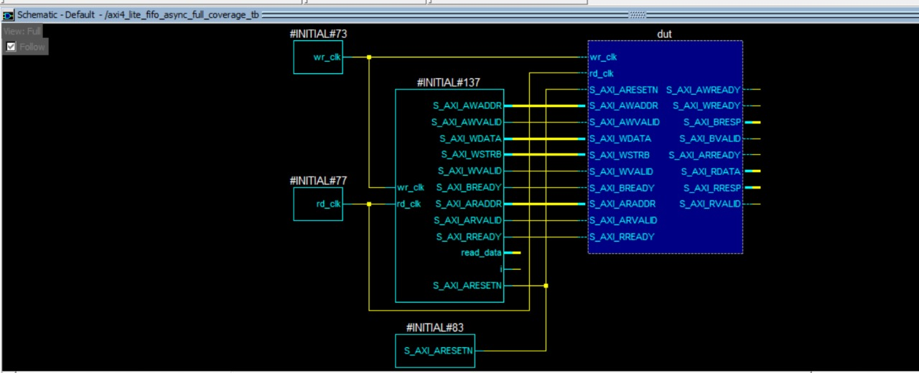

Figure 4.1.2:- Schematic View of Testbench and DUT Connectivity
The Figure 4.1.2 presents the top-level architecture of the verification environment. It provides a visual representation of how the testbench modules are interconnected with the Device Under Test (DUT), ensuring that the design is properly stimulated and monitored during simulation.
- Testbench Environment: The schematic shows the testbench's key components, including signal drivers for the independent clocks (wr_clk, rd_clk) and the asynchronous reset (S_AXI_ARESETN). These signals are correctly supplied to the DUT, which is crucial for verifying asynchronous behavior.
- Device Under Test (DUT): The central blue box represents the axi4_lite_fifo_async module. It is the core of the design, containing all the logic for the AXI4-Lite protocol and the asynchronous FIFO functionality.
- Signal Connections: The schematic verifies that all AXI4-Lite signals are correctly connected from the testbench to the DUT. This includes the write address, write data, write response, read address, and read data channels. The diagram provides a clear path for tracing the flow of data and control signals from the testbench to the design and back.

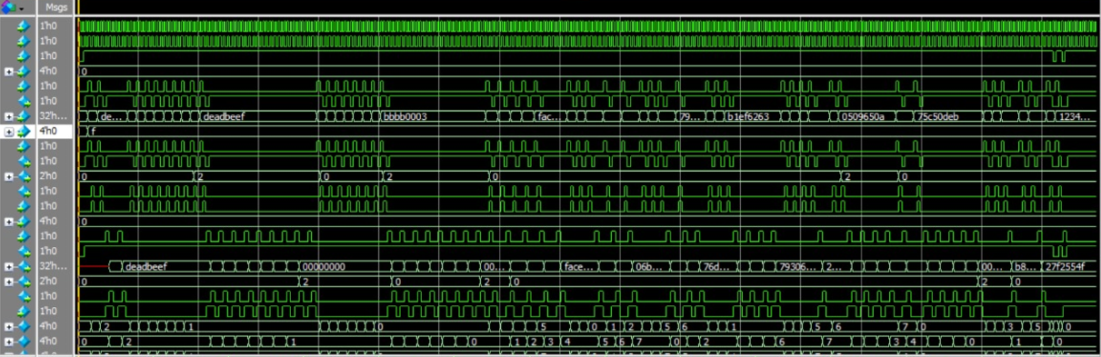
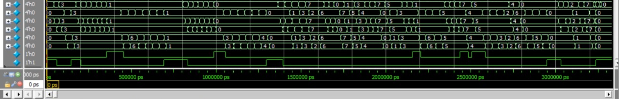
Fig 4.1.3 : Waveform of AXI4 Lite Asynchronous FIFO
The waveform shown represents the functional verification of the AXI4-Lite based Asynchronous FIFO design. It highlights both write operations and read operations across the two independent clock domains.

1. Clock Signals
- The top-most signals represent the write clock (wclk) and read clock (rclk).
- These clocks are asynchronous, operating at different frequencies, which validates the robustness of the FIFO design in handling asynchronous communication.

2. Write Channel (AW/W Signals)
- The write data bus (WDATA) shows multiple 32-bit values being written into the FIFO, such as:
  - deadbeef, bbbb0003, face1234, etc.
- The write enable signals (WVALID, WREADY) indicate successful handshaking between the AXI master and FIFO.
- Whenever WVALID and WREADY are both high, the corresponding data word is written into the FIFO memory.

3. Read Channel (AR/R Signals)
- The read data bus (RDATA) shows the data being read from the FIFO:
  - Initially, values such as deadbeef, 00000000, face06b7, 79306213, etc. appear.
- The read handshake signals (RVALID, RREADY) confirm the successful read transaction from FIFO to the AXI master.
- The data integrity is maintained as the values written earlier are exactly retrieved on the read channel after crossing the clock domains.

4. Address and Response Signals
- The address lines (AWADDR, ARADDR) show the memory-mapped locations targeted during write and read transactions.
- The response signals (BRESP, RRESP) remain 00 throughout the simulation, which indicates successful transactions without errors.

5. FIFO Behavior
- The waveform shows that the FIFO buffer is operating correctly:
  - The write operations store the incoming data sequentially.
  - The read operations retrieve the same data in correct order (First-In-First-Out).
- Even though the write and read clocks are asynchronous, data is safely transferred across the domains without corruption.

4.2 Limitations
One of the primary limitations of this project is that the work completed so far is restricted to the design and verification of the AXI4 module in simulation. The project has not yet been extended to full system-level integration with other peripherals such as memory controllers, processors, or interconnects. As a result, the current verification environment validates only protocol compliance and functional correctness of the AXI4 block, but does not account for system-level bottlenecks, arbitration conflicts, or latency impacts that may occur in a complete SoC environment.
Another limitation is the focus on functional verification without incorporating extensive performance verification. While correctness of read and write transactions has been established, key performance aspects such as throughput under heavy traffic, handling of multiple outstanding transactions, and stress testing of backpressure scenarios have not yet been exhaustively validated. Similarly, power consumption and area overhead of the AXI4 implementation were not analyzed in this phase, leaving out hardware-level optimization aspects.
Additionally, the verification process primarily relied on simulation-based techniques using SystemVerilog and UVM. Although this approach is powerful, it is still limited by the coverage of the written test scenarios. Formal verification or hardware emulation, which could provide stronger guarantees of correctness, were not employed in this stage of the project. Thus, there remains a small possibility of corner-case bugs that might only appear under rare system conditions.
Finally, the project scope was limited to the slave-side verification of AXI4, while advanced features such as AXI4-Lite, AXI4-Stream, and master-side verification were not implemented. This restricts the completeness of the current results, as a full AXI4 verification IP would ideally cover all variants of the protocol and ensure interoperability across different configurations.

Chapter 5
CONCLUSION AND FUTURE SCOPE
Conclusion
The design and verification of the AXI4 Asynchronous FIFO using UVM have been successfully carried out as part of the initial phase of this project. The work primarily focused on developing a reliable RTL design of the FIFO, followed by functional verification through simulation in Mentor QuestaSim. The FIFO was designed to interface with AXI4 protocols, thereby ensuring compatibility with industry-standard SoC interconnect systems. The design incorporated essential elements such as write and read pointers, full and empty flag generation, and handshake-based synchronization to safely transfer data between two independent clock domains. These features are crucial in asynchronous systems where data integrity and metastability handling are of utmost importance.
Simulation results clearly demonstrated correct behavior for fundamental operations. Write transactions were successfully performed when the FIFO was not full, and read operations were completed when data was available in the buffer. The control signals such as tvalid, tready, full, and empty responded as expected, validating the handshake mechanism. The correctness of data transfer was confirmed through read-after-write checks, thereby verifying the core functionality of the FIFO. Furthermore, by integrating AXI4 protocol-specific signals into the design, the FIFO achieved seamless communication with AXI masters and slaves, a key requirement for modern SoC design.
Equally important was the development of the verification environment. Using UVM as a structured methodology, the project established a reusable and scalable testbench framework. The testbench included stimulus generation, monitors for observing DUT behavior, and checkers to validate correctness. Even though the present phase emphasized directed and basic functional tests, the foundation has been laid for more advanced verification flows. The methodology ensured that the design could be validated against multiple scenarios while maintaining modularity and extensibility for future stages of the project.
Overall, the results obtained in this phase strongly support the functional correctness of the design. The successful RTL implementation and its verification confirm that the AXI4 Asynchronous FIFO can reliably handle communication across different clock domains. This lays a solid groundwork for scaling the design and applying more rigorous verification strategies in subsequent phases.
Future Scope
Although the current phase of the project successfully demonstrated the correctness of the AXI4 asynchronous FIFO design and its seamless integration with protocol-level interfaces, there are multiple avenues to enhance both the design and verification methodology for future development. One important area of improvement is the expansion of verification using constrained-random and coverage-driven testing. By incorporating constrained-random test generation, a wider range of input combinations can be explored automatically, including challenging stress scenarios such as simultaneous reads and writes, boundary conditions when the FIFO is nearly full or empty, and randomized burst lengths. Coverage-driven verification allows for quantitative measurement of verification completeness, ensuring that all critical operational scenarios are exercised and validated, which significantly improves confidence in the design’s robustness.
Another promising enhancement involves the introduction of assertion-based verification (ABV) using SystemVerilog assertions. Assertions act as continuous monitors during simulation, automatically checking protocol compliance and identifying illegal conditions as they occur. For example, assertions can validate proper handshake sequences, detect FIFO underflow or overflow conditions, and ensure accurate synchronization across the write and read clock domains. The inclusion of ABV not only strengthens the verification process but also reduces debugging time by quickly pinpointing the source of potential errors, ultimately improving overall design reliability.
Since asynchronous FIFOs are inherently used in clock-domain crossing scenarios, formal verification methods present a significant opportunity for future work. Formal verification uses mathematical proofs to confirm the absence of metastability hazards and other timing-related issues that could compromise data integrity. By combining formal verification with traditional simulation-based methods, the FIFO design can be validated with a higher degree of confidence, even under extreme corner-case conditions that may be difficult to reproduce through simulation alone. This approach enhances the reliability of the FIFO and ensures its suitability for integration into complex SoC designs.
Hardware-level validation is another critical step in the future scope of the project. Implementing the asynchronous FIFO on FPGA platforms allows designers to evaluate the design in real-time, measuring key performance parameters such as latency, throughput, resource utilization, and operating frequency. FPGA prototyping provides practical insights that are not easily observable in simulation alone and helps identify potential bottlenecks or inefficiencies before integration into larger SoC systems. This real-time evaluation is essential for ensuring that the design meets performance requirements under actual operating conditions.
Further future work involves integrating the FIFO into more complex AXI-based SoC subsystems. In such scenarios, the FIFO can act as a data buffer between high-speed and low-speed modules or between multiple processors and peripheral devices. End-to-end validation within a system-level testbench allows designers to assess the FIFO’s role in realistic communication scenarios, verifying its performance, reliability, and protocol compliance under full system operation. This integration also provides insights into how the FIFO interacts with other IP blocks and enables fine-tuning for optimal performance in practical applications.
Performance optimization is another important direction for future enhancement. Optimizing FIFO depth, reducing latency, and improving throughput can significantly increase the efficiency of the design without compromising correctness. Potential enhancements include look-ahead read mechanisms, optimized full and empty flag generation, and reduced pointer update logic. These optimizations can help the FIFO achieve higher performance and lower resource utilization, making it more suitable for high-speed, resource-constrained environments in modern SoCs.
Finally, the design can be extended to support multi-channel or interleaved AXI4 streams, reflecting the practical requirements of real-world SoCs where multiple data streams may need to be buffered and synchronized simultaneously. Multi-channel FIFO support increases the versatility of the design, enabling it to handle several concurrent transactions while maintaining protocol compliance and data integrity. This scalability makes the asynchronous FIFO a more valuable and reusable IP block for future SoC designs, supporting the growing demand for high-throughput, reliable on-chip communication solutions.
In conclusion, the future scope of the AXI4 asynchronous FIFO encompasses advanced verification, assertion-based monitoring, formal proofs of reliability, FPGA prototyping, system-level integration, performance optimization, and scalability to multi-channel systems. By pursuing these enhancements, the design can be transformed into a highly robust, efficient, and versatile IP core that meets the demanding requirements of modern high-performance SoCs, while also offering reusability and industry-grade reliability for future projects.
The next logical step is to expand the verification methodology by incorporating constrained-random test generation. This will enable automatic exploration of a wide range of input combinations, including stress cases such as simultaneous reads/writes, boundary conditions when the FIFO is nearly full or empty, and randomized burst lengths. Coverage-driven verification will allow quantitative measurement of verification completeness, ensuring that all critical scenarios have been exercised.
Other Scopes are:

- Assertion-Based Verification (ABV) :
Introducing SystemVerilog assertions (SVA) will strengthen the verification process by continuously monitoring protocol compliance and detecting illegal conditions during simulation. Assertions can be applied to ensure proper handshake sequences, absence of underflow/overflow, and correct synchronization across the clock domains. This will improve verification efficiency and reduce debugging time.

- Formal Verification for Clock-Domain Crossing (CDC) :
Since asynchronous FIFOs are primarily used in CDC scenarios, formal verification methods can be applied to mathematically prove the absence of metastability-related hazards. By combining simulation-based and formal approaches, the reliability of the design can be validated with higher confidence, even under corner-case conditions.

- FPGA Prototyping and Hardware Validation :
Another future step involves synthesizing the design and implementing it on FPGA hardware platforms. Hardware prototyping will allow real-time evaluation of parameters such as latency, throughput, resource utilization, and operating frequency. This will also validate the design’s suitability for integration into larger SoC systems.

- Integration into AXI-Based SoC Subsystems :
The asynchronous FIFO can be connected to AXI4 masters and slaves within a more complex SoC testbench. This will provide end-to-end validation of the FIFO’s role in actual system-level communication scenarios, such as data buffering between processors and peripherals, or between high-speed and low-speed clock domains.

- Performance Optimization :
Future iterations can focus on optimizing FIFO depth, reducing latency, and improving throughput. Design enhancements like introducing look-ahead read mechanisms, optimizing full/empty flag generation, or reducing pointer update logic can help achieve better performance without compromising correctness.

- Scalability to Multi-Channel Systems :
In practical SoCs, multiple AXI4 streams may need to be buffered and synchronized simultaneously. Extending the FIFO design to support multi-channel or interleaved transactions can make it more versatile and directly applicable to real-world communication systems.

References
[1]. Harish T. L., Chandrashekhar M. C., Eshwarappa M. N., “SystemVerilog Verification Techniques for AXI4 Slave Devices: A Practical Approach,” International Journal of Human Computations & Intelligence, 2023.
[2]. Yatheeswar Penta, Riadul Islam, “Design and Verification of a Synchronous First-In-First-Out (FIFO),” arXiv preprint, 2025.
[3]. C. Anusha Bhanu, Rajesh Odela, G. R. Padmini, “Coverage Driven Verification of Synchronous FIFO using UVM,” Recent Trends in Electronics and Communication Systems, STM Journals, 2023.
[4]. Aman Kumar, Muhammad Ul Haque Khan, Bijitendra Mittra, “Pragmatic Formal Verification Methodology for Clock Domain Crossing (CDC),” arXiv preprint, 2024.
[5]. ARM Ltd., “AMBA AXI and ACE Protocol Specification, AXI3, AXI4, and AXI4-Lite, IHI 0022E,” 2010.
[6]. S. Kilts, “Advanced Verification Strategies for AXI-Based IP Cores Using UVM,” IEEE International Conference on VLSI Design and Test (VDAT), 2022.
[7]. P. Sharma, R. Gupta, “Assertion-Based Verification of AXI4 Protocol using SystemVerilog,” International Journal of VLSI Design & Communication Systems (VLSICS), Vol. 11, No. 3, 2020.
[8]. Synopsys Inc., “AXI4 Verification IP User Guide,” Synopsys Documentation, 2021.
[9]. Mentor Graphics, “Questa Advanced Simulator – AXI Verification Flow,” 2022.

